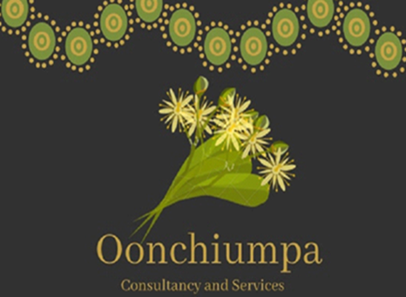

Oonchiumpa Consultancy and Services

24 Parsons Street

Alice Springs NT 0870

Phone: 0474 702 523

Email: [admin@oonchiumpaconsultancy.com.au](mailto:admin@oonchiumpaconsultancy.com.au)

***“Two Cultures, One World, Working Together”***

**Good News Story**

**Atnarpa Station Field Trip**

On the 4th on July Myself and 3 of clients had travelled to Atnarpa Homestead for a healing and connection to country day trip. The trip was a very successful one, during our time there the family of Atnarpa Station where conducting a tour of interstate students there and they were able to see firsthand of sharing knowledge of their own country and the importance of making bush medicines that has been passed down from their elders, storytelling and the sharing the history of that area.

The young men were able to express how they were feeling and that opened to a lot of discussions. I spoke we with them about learning and self-identity. Where they come from and their own connection to land and country.

My family at Atnarpa at the time of our visit had a school group of 29 students from interstate learning on country. The three where able to see firsthand to what my kids and partner do. That made them question about the things and why does my family do this and would they be able to do something like that. I spoke to them about its never to late to do anything like that and to get involved with stuff like it they were very overwhelmed.

We then went up to the fire pit to start cooking the kangaroo tails, this then led to the conversation on who knows how to hunt kangaroo and cook it. One of the young men was questioned by the other two on why and where he’s connection was. The young men where able to speak about it together and I was very happy that they were able to open and talk to me about those things.

I told Malachi it’s not too late to learn these things of your family background and connection to country, I told him he’s in the best position of going back to learn these things because off he’s family. Malachi has family that have started to reconnect back to country by opening their own school to teach the next generation of a language that was on the brink of extinction.

Malachi has since returned to he’s country with he’s extended family members. He is involved with visitors from different countries, non-indigenous students that recently visited he’s homelands. I think that this has improved his behaviour, because he wanted to learn and be a part of he’s family connection to country and to learn knowledge as he participated. I see this as a great empowerment to him and I’m very happy with the outcome.

